Fenwick tree / BIT

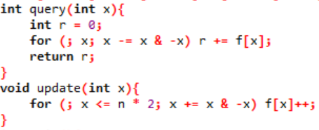range query / point update:

if wanna point query / range update, just Fenwick on the difference array

range update / range query

